

**LEARN TO TYPE!**

**Instruction Manual**

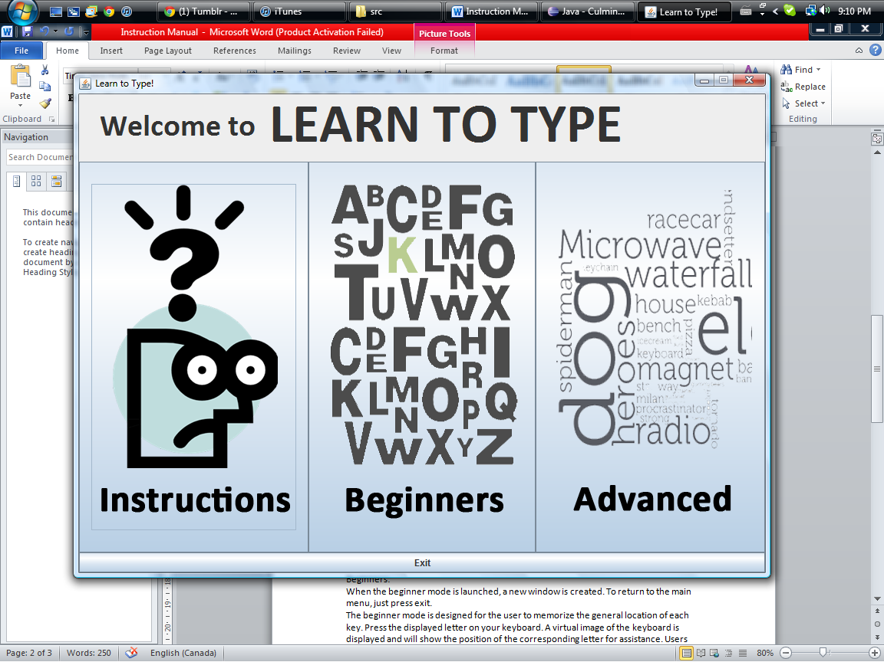Welcome to Learn to Type, a simple program designed to help people familiarize themselves with the QWERTY keyboard. The following is a screen shot of the main menu.

There are three main parts to this program: Instructions, for Beginners and for Advanced users. Large buttons are displayed at the main menu to easily access each mode. Clicking on each one will lead you to the specific section. The menu has a clean design and is extremely simple and easy to use.

The program can be closed by the x in the top-right-hand corner or the exit button located at the bottom.

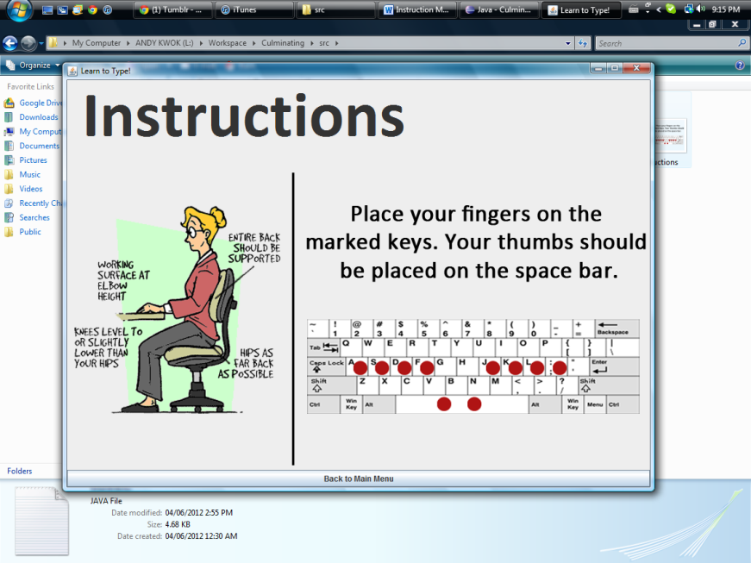Instructions:

This section shows the user the proper sit posture and hand positions while typing. There are visual diagrams for the user to refer to. To return to the main menu press the back button located at the bottom of the screen.

Beginners:

The beginner mode is designed for you to memorize the general location of each key. The objective of the beginner mode is to press the displayed letter on your keyboard. A virtual image of the keyboard is displayed and will show the position of the corresponding letter for assistance. The program will tell you if you are correct of the right side.

For a challenge you can test your speed by pressing start at anytime. By pressing start, the user has thirty seconds to press as many correct keys as possible. A 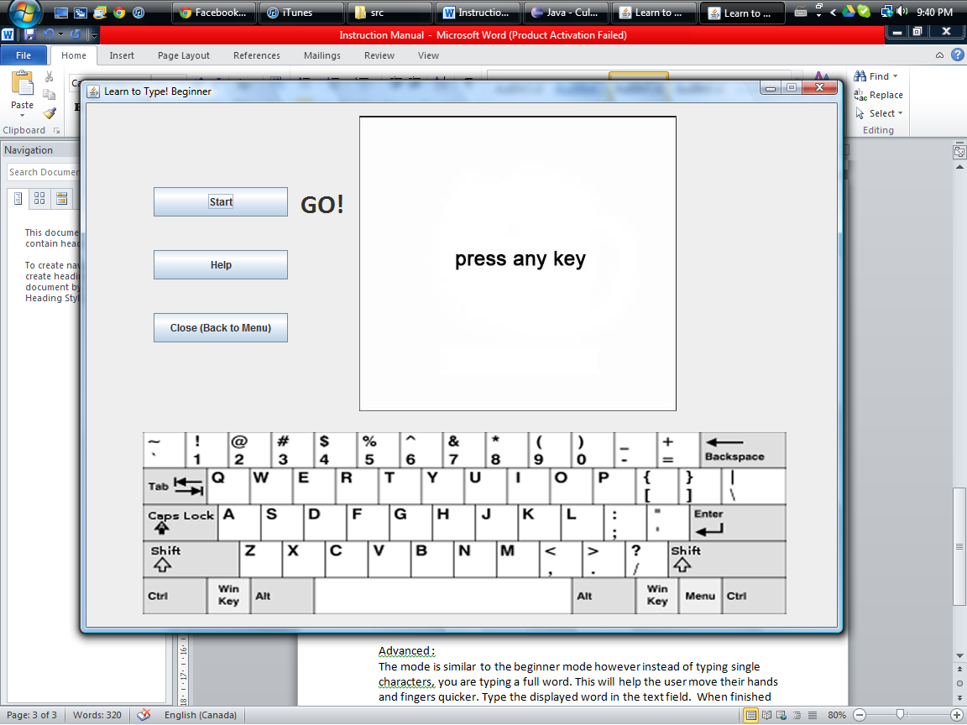 sign will appear beside the start button to indicate that time has started. When time is up, your stats will be shown.

When the beginner mode is launched, a new window is created. To return to the main menu, just press Close on the left side.

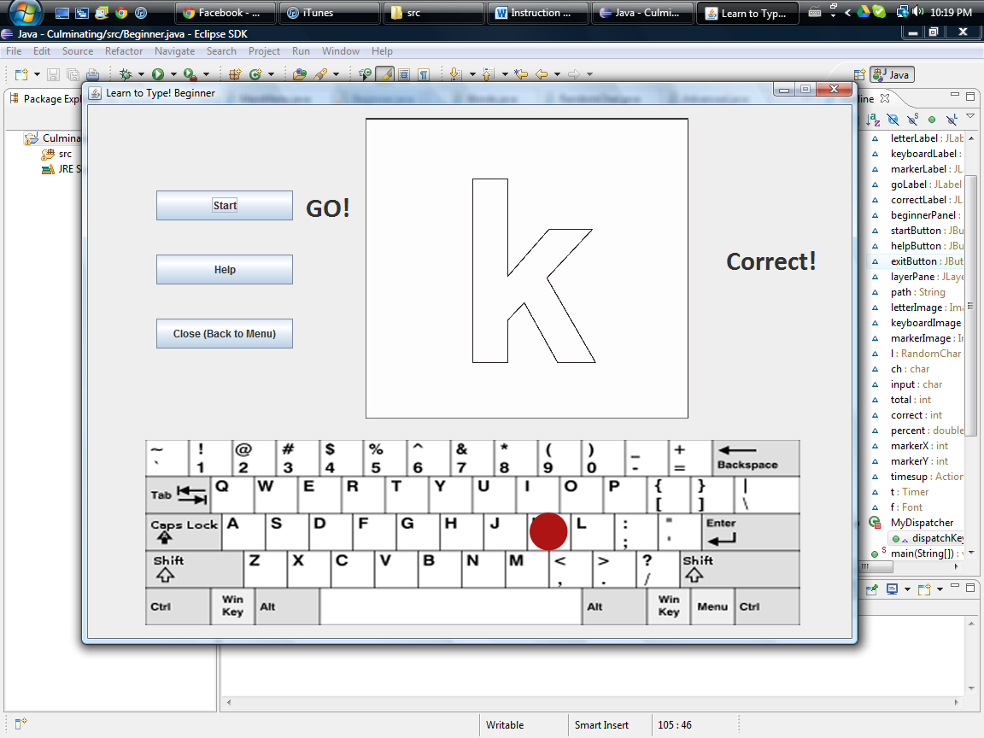

1. Start Button
2. Help Button
3. Close Button
4. Go Label
5. Correct Label
6. Displayed Letter
7. Virtual Keyboard

4

1

5

2

6

3

7

Advanced :

In the Advanced mode you type a full a full word. This will help you improve moving your hands and fingers around the keyboard quickly.

A random word will be displayed in the window. Type the displayed word in the text field. When finished, press “next word”. If you are correct a new word will be displayed. If not, the program will ask you to try again. The total number of words typed in a row without mistakes is displayed at the bottom.

When the advanced mode is launched, a new window is created. To return to the main menu, just press Close on the left side.

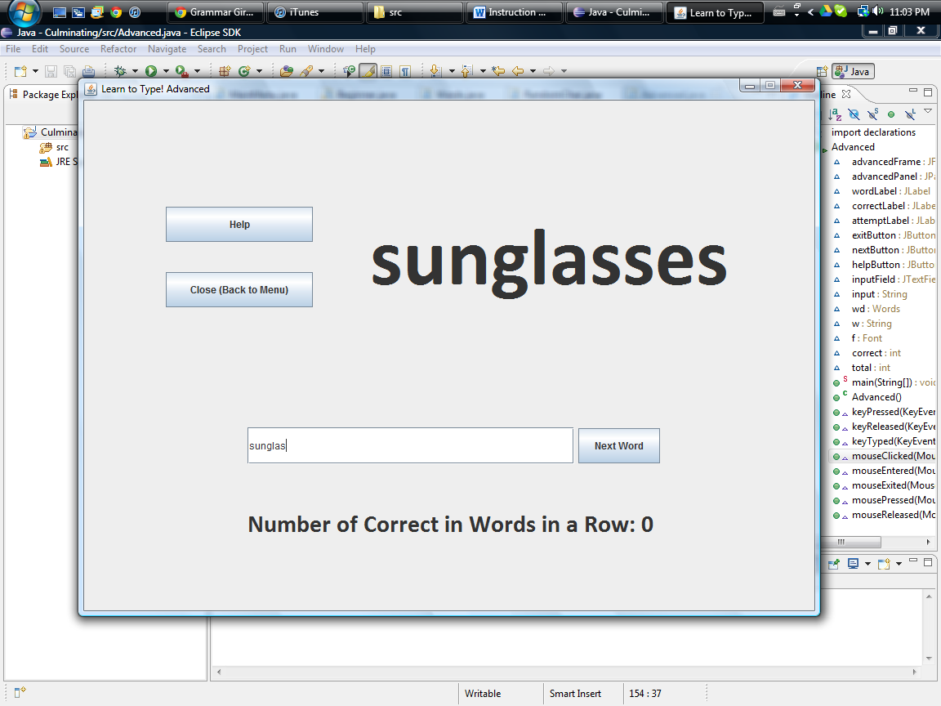

1. Displayed Word
2. Help Button
3. Close Button
4. Input Field
5. Next Button
6. Correct Words Counter

2

1

3

5

4

6

For further assistance, please refer to the help buttons within the program.